WEEK 1

**1. The robot has six degrees of freedom**

How many different ways can you rotate or translate the robot?

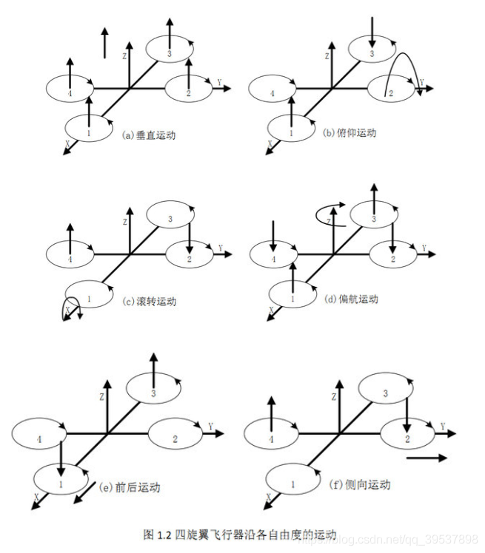

Yaw, Roll, Pitch

**2. In any system, ask how the following components work!**

State Estimation

Control

Mapping (SLAM）

Planning

3. Basic Mechanics (Hover)

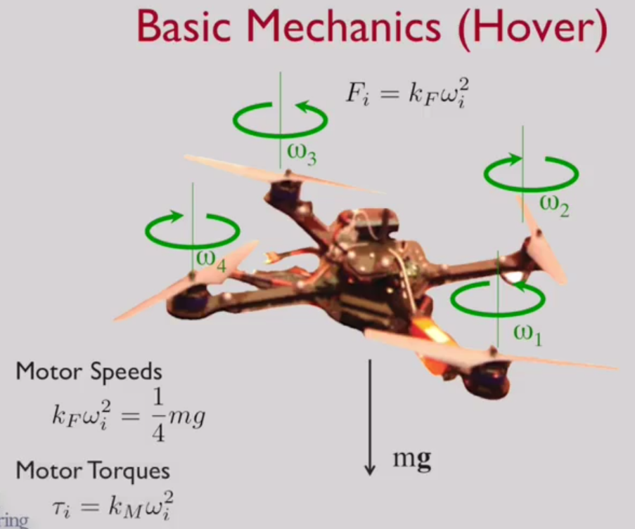

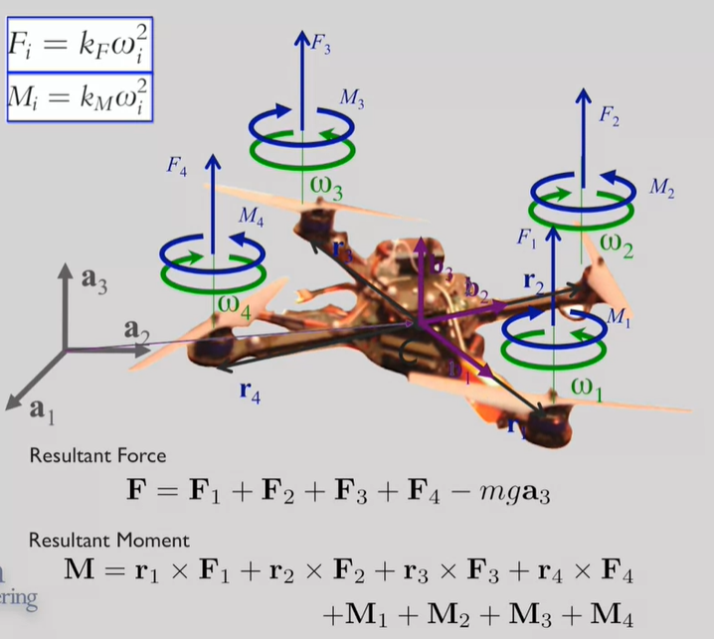

**3.1. Dynamics and 1-D Linear Control**

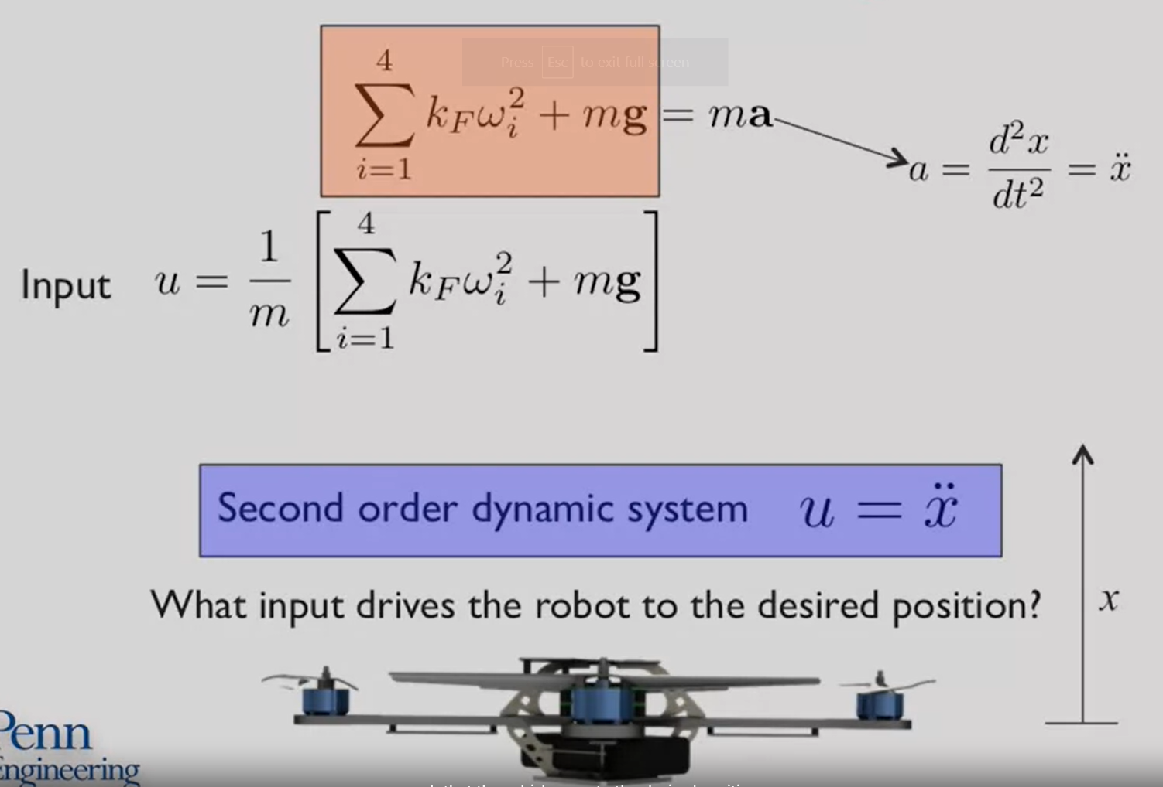

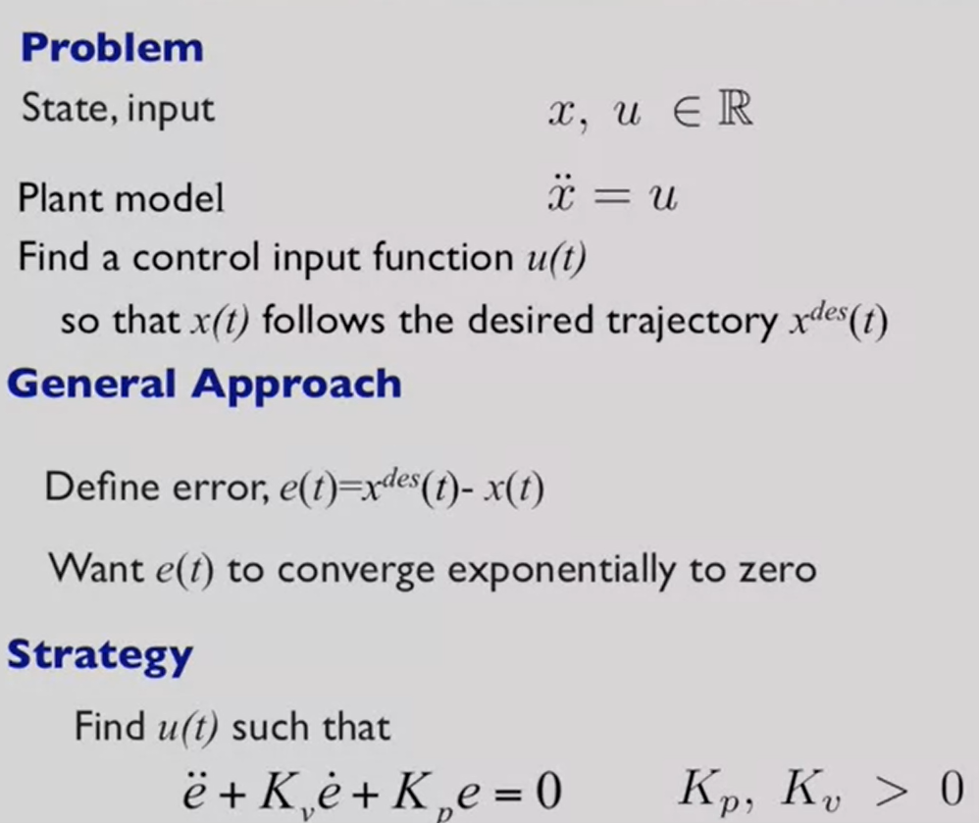

**PD control**



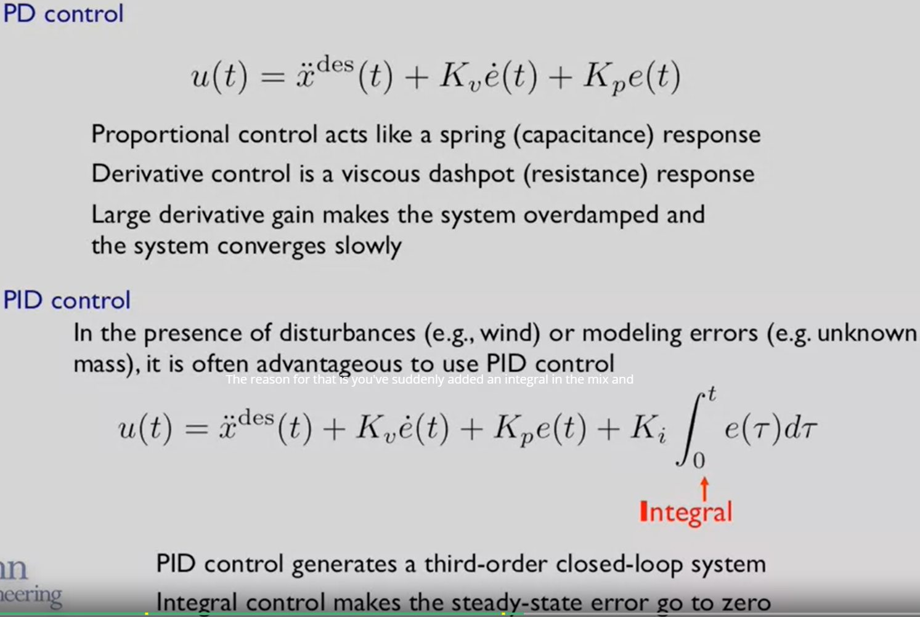

3.2. Design Considerations

Assume that we know maximum thrust

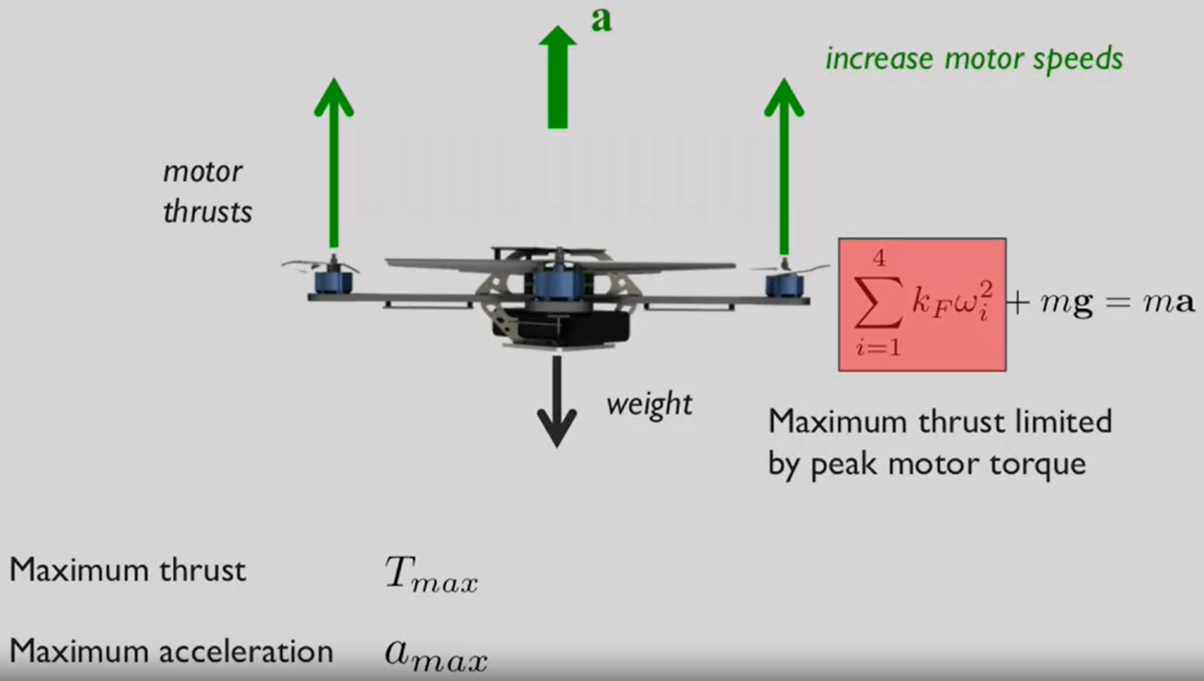

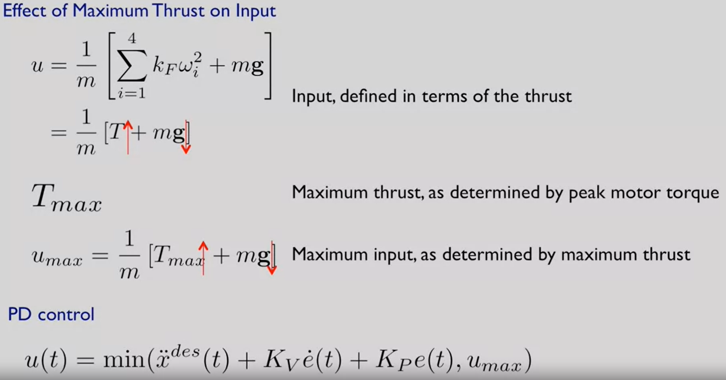

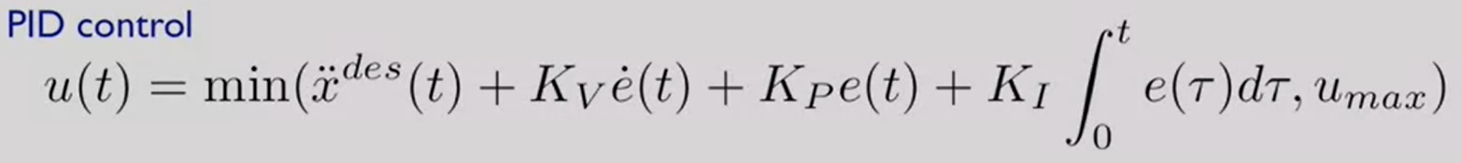

When consider system design, we must think about battery selection and power consumption

3.3. Agility and Maneuverability (nhanh nhẹn và cơ động)

- Maximum velocity to rest:

Maximize agility: minimize stopping distance

- Turn quickly without slowing down:

Maximize agility: minimize minimum turning radius

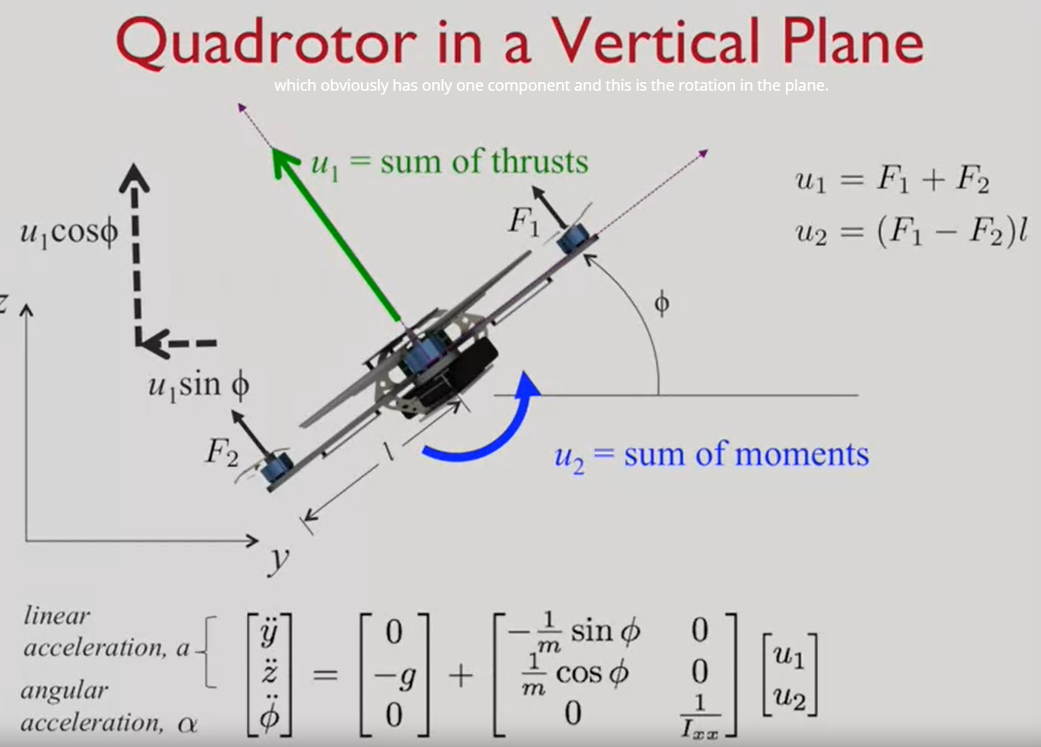

Two key ideas:

* Accelerate qickly

->maximize $a_{max}$ (linear acceleration) -> maximize $\frac{u_{1,max}}{W}$ (thrust/weight)

- Roll/pitch quickly

Maximize $α_{max}$ (angular acceleration) -> maximize $\frac{u_{2,max}}{I_{xx}}$ (moment/inertia along x)

3.4. Component Selection

3.5. Effect of size

